  - Domain and Database
A new website must be defined by having a domain pointing to the server where the files are hosted. For testing purposes two (2) environments are created.
This document guides you to create one (1) main domain, one (1) sub domain, and install two (2) separate databases for your website.

Domain

Definition
Main Domain: yourdomain.com
Sub Domain: dev.yourdomain.com
From the control panel which can be access thru http://yourwebsite.com/cpanel (if the website is being hosted with hostgator), follow this instructions:

Create yourdomain.com

Go to -> Domains -> Addon Domains
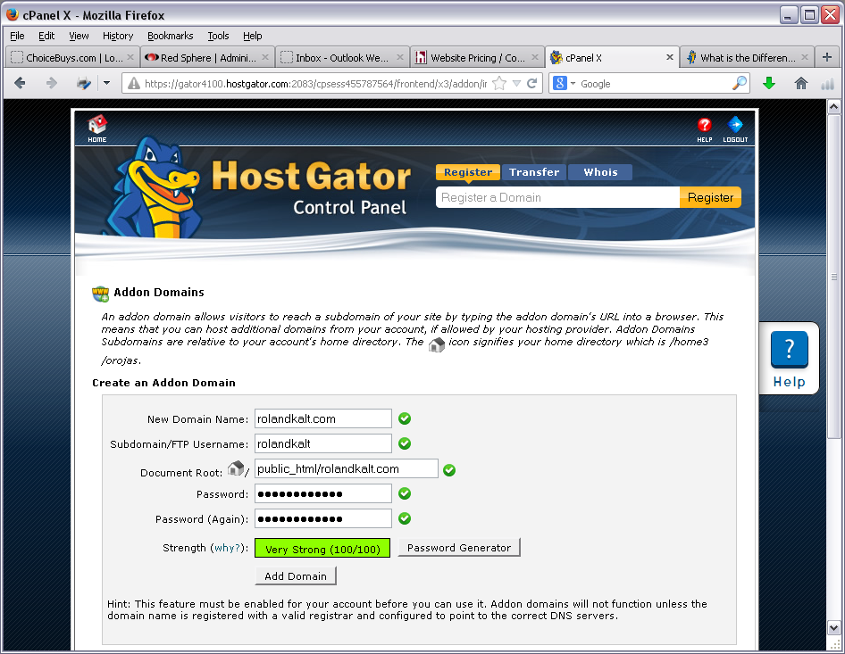
yourdomain.com
ftpusername
yourdomain.com

Create dev.yourdomain.com

Go to Domains -> Subdomains
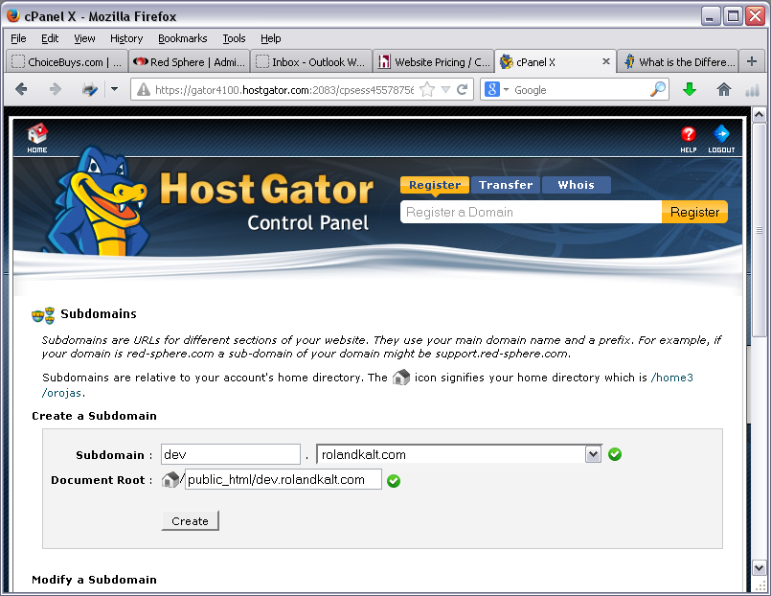
dev.yourdomain.com
yourdomain.com

MySql Databases

Create New Database, Add New User and Assign
Usually two (2) databases are created: 1 for Dev, 1 for Live.

Create New database

Go to Databases -> MySQL Databases
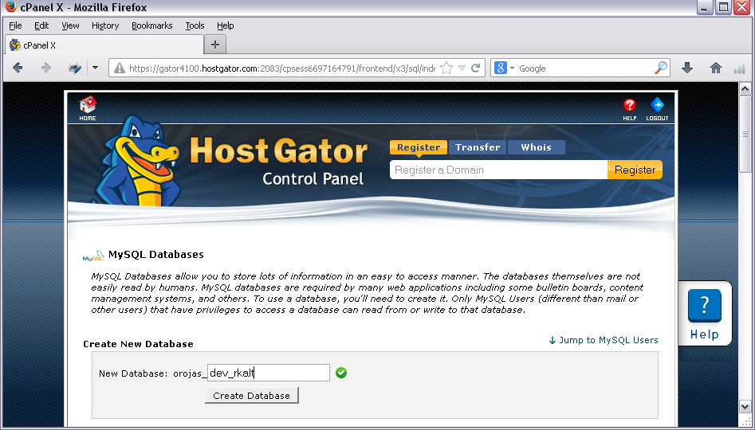
user_
yourdbname

Add New User.

Go to Databases -> MySQL Databases -> Add New User
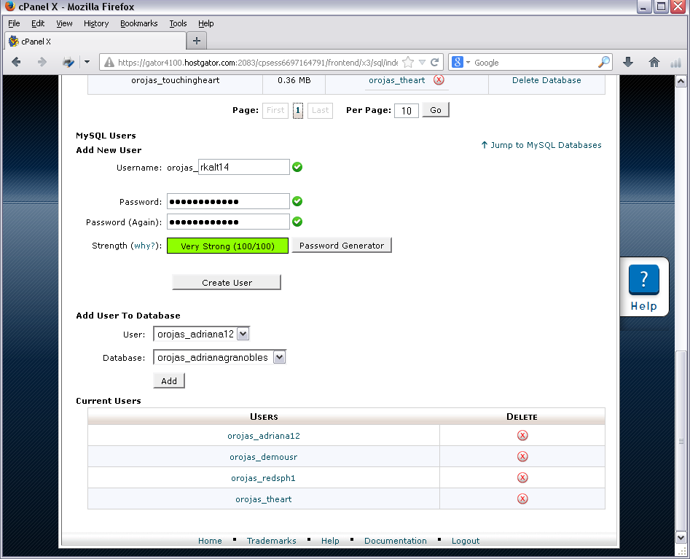
user_
yourdbuser

Assign user to database.

Go to Databases -> MySQL Databases ->Add user to database
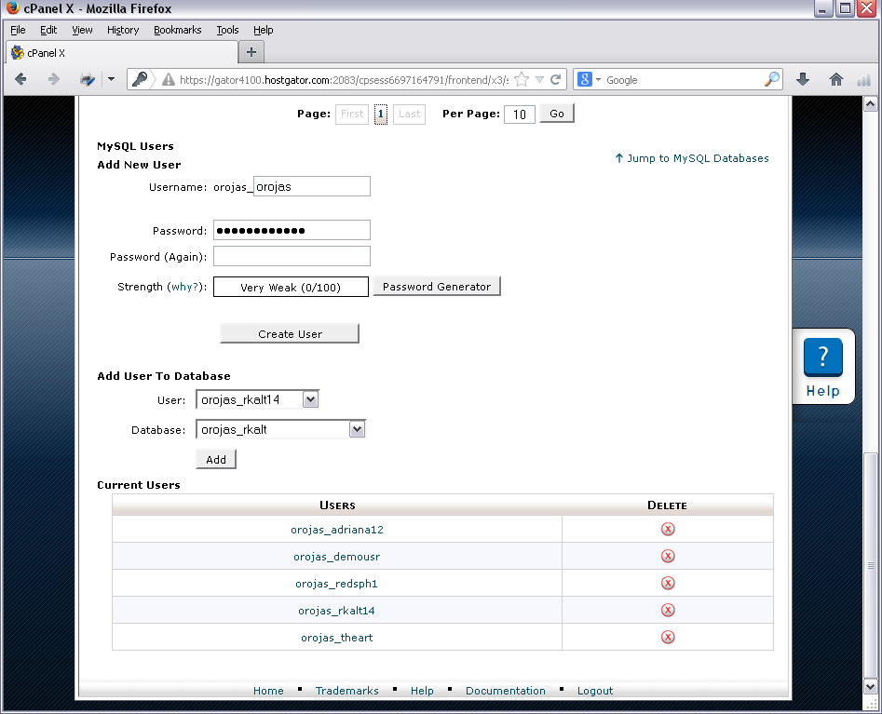
user_yourdbname
user_yourdbuser

Connect and run database query
You can connect to your database in two ways:
- Using “phpmyadmin” panel from the cpanel of your hosting provider.
- Download and install heidiSQL. http://www.heidisql.com/.
To connect using heidiSQL to a hostgator database hosting, you must add permissions to connect to your db from your external IP.
- http://www.whatismyip.com/
- Go to Databases -> Remote MySQL

